**SQL | Join (Inner, Left, Right and Full Joins)**

**Student**

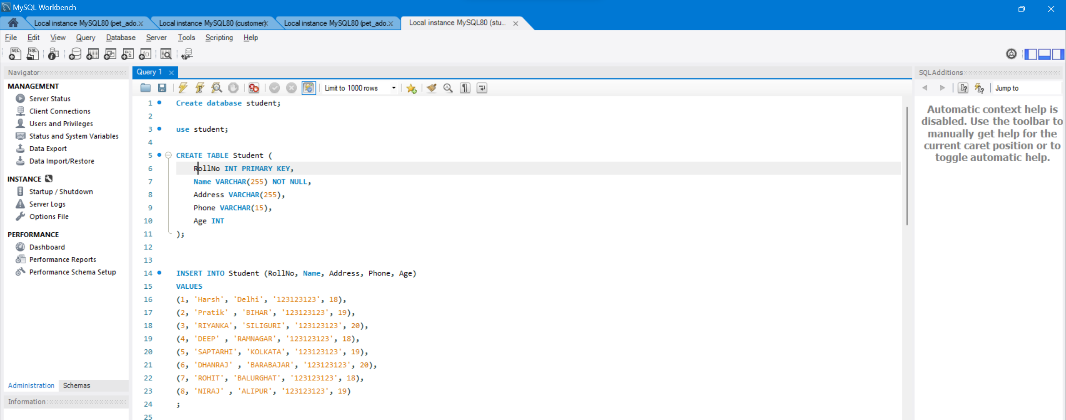

**StudentCourse**

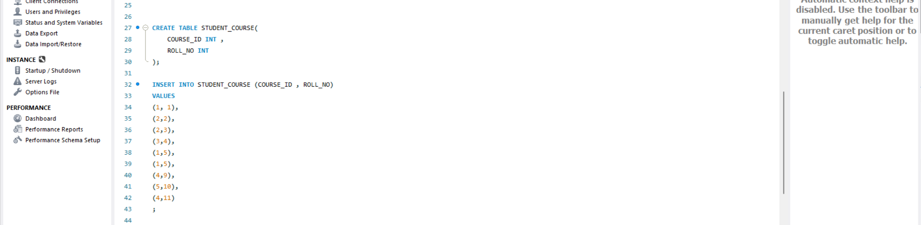

The simplest Join is INNER JOIN.

**A. INNER JOIN**

The INNER JOIN keyword selects all rows from both the tables as long as the condition is satisfied. This keyword will create the result-set by combining all rows from both the tables where the condition satisfies i.e value of the common field will be the same.

**Syntax**:

SELECT table1.column1,table1.column2,table2.column1,....  
FROM table1   
INNER JOIN table2  
ON table1.matching_column = table2.matching_column;  
  
  
**table1**: First table.  
**table2**: Second table  
**matching_column**: Column common to both the tables.

***Note****: We can also write JOIN instead of INNER JOIN. JOIN is same as INNER JOIN.*

**Example Queries(INNER JOIN)**

This query will show the names and age of students enrolled in different courses.

SELECT Student.COURSE_ID, Student.NAME, Student.AGE FROM Student  
INNER JOIN StudentCourse  
ON Student.ROLL_NO = StudentCourse.ROLL_NO;

**Output**:

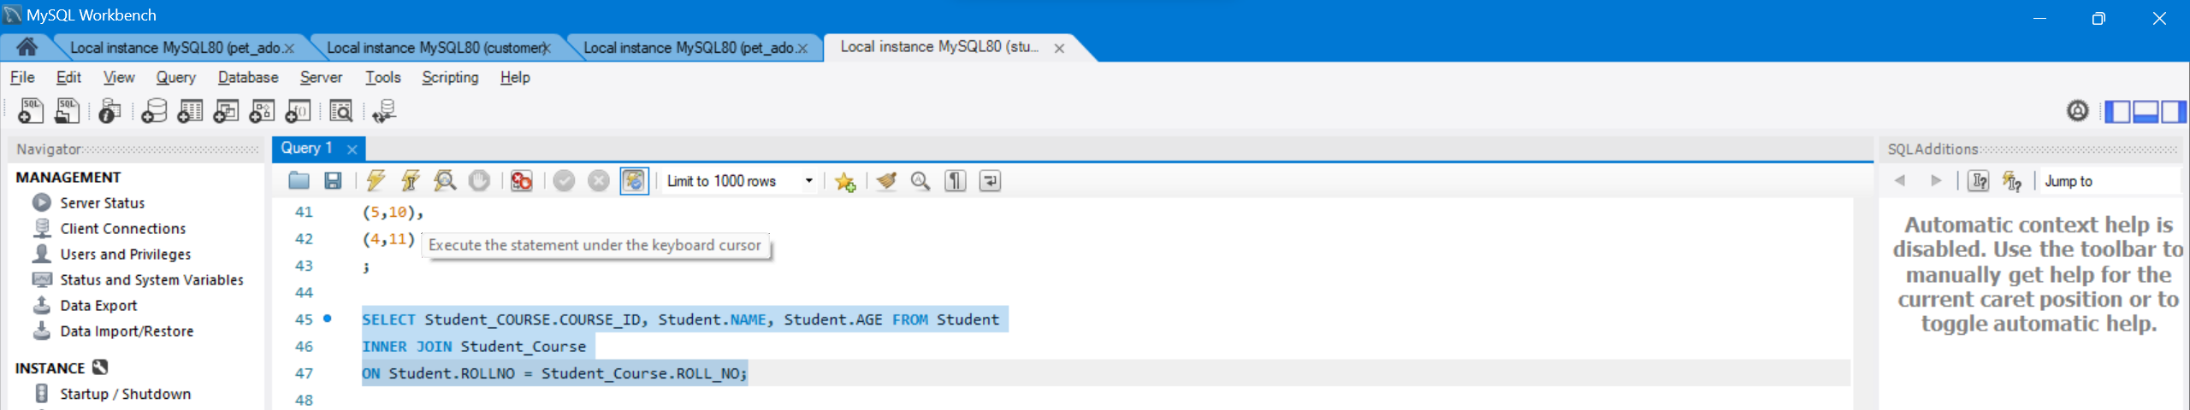

**B. LEFT JOIN**

This join returns all the rows of the table on the left side of the join and matches rows for the table on the right side of the join. For the rows for which there is no matching row on the right side, the result-set will contain *null*. LEFT JOIN is also known as LEFT OUTER JOIN.

**Syntax:**

SELECT table1.column1,table1.column2,table2.column1,....  
FROM table1   
LEFT JOIN table2  
ON table1.matching_column = table2.matching_column;

**Output**:

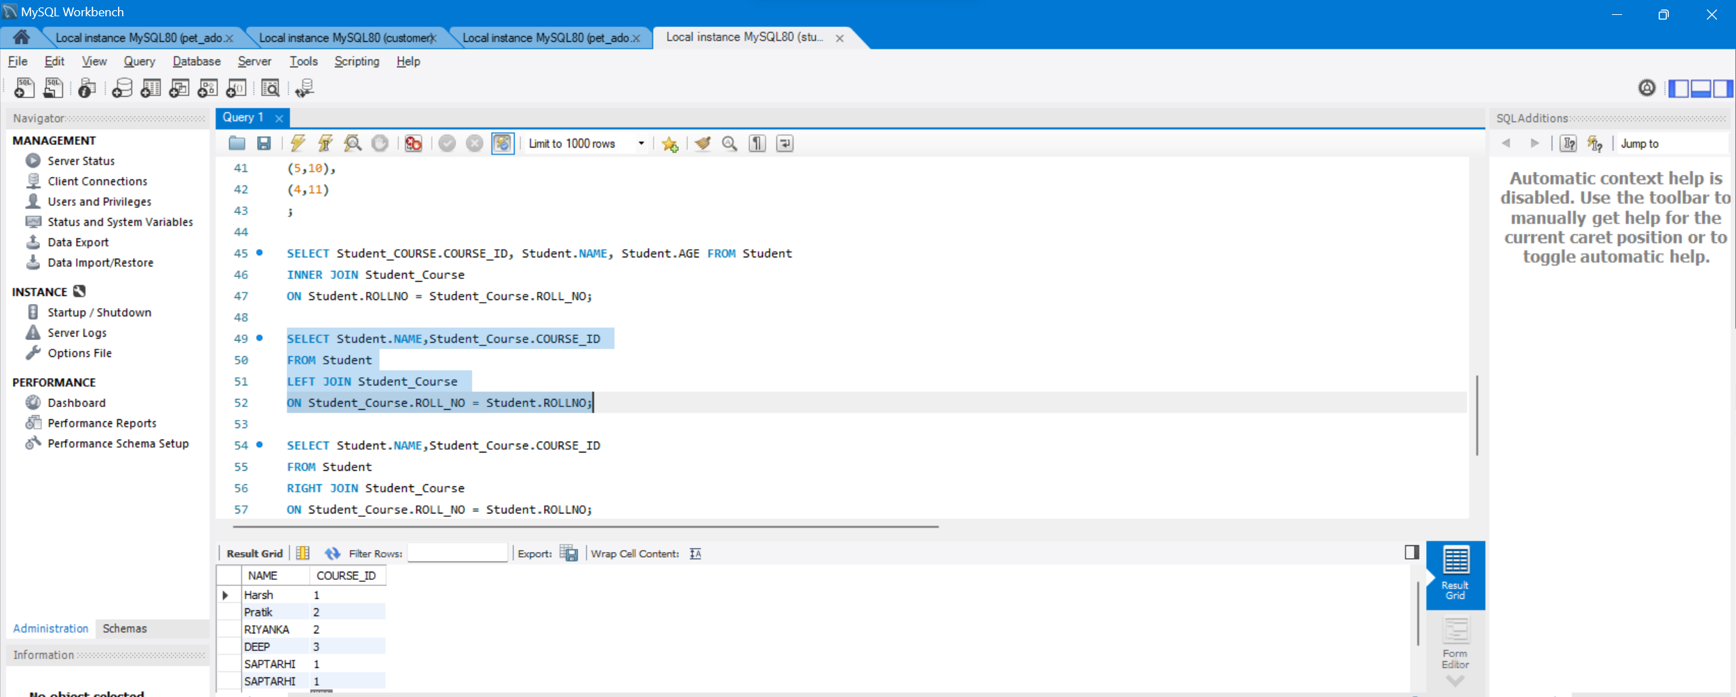

**C. RIGHT JOIN**

RIGHT JOIN is similar to LEFT JOIN. This join returns all the rows of the table on the right side of the join and matching rows for the table on the left side of the join. For the rows for which there is no matching row on the left side, the result-set will contain *null*. RIGHT JOIN is also known as RIGHT OUTER JOIN.

**Syntax:**

SELECT table1.column1,table1.column2,table2.column1,....  
FROM table1   
RIGHT JOIN table2  
ON table1.matching_column = table2.matching_column;  
  
**Output:**

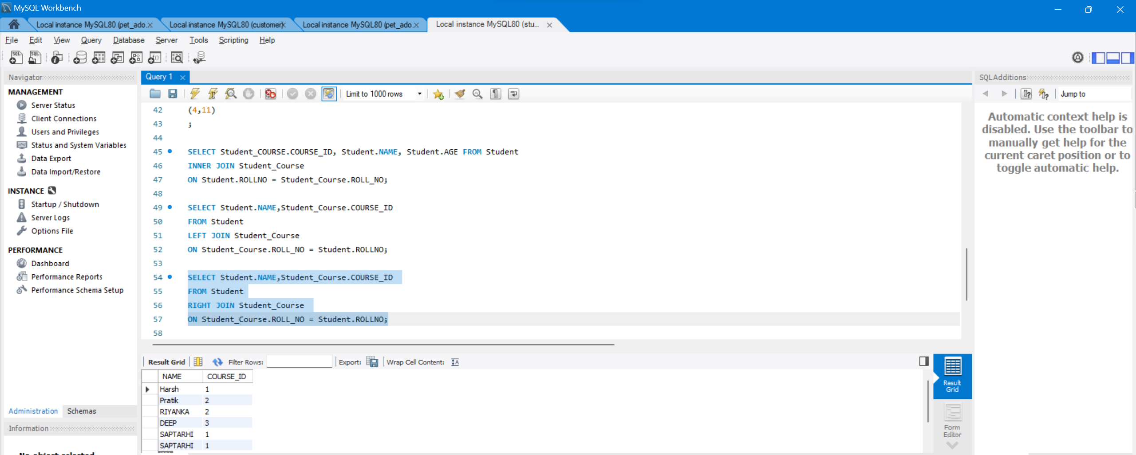

**D. FULL JOIN**

FULL JOIN creates the result-set by combining results of both LEFT JOIN and RIGHT JOIN. The result-set will contain all the rows from both tables. For the rows for which there is no matching, the result-set will contain *NULL* values.

**Syntax:**

SELECT table1.column1,table1.column2,table2.column1,....  
FROM table1   
FULL JOIN table2  
ON table1.matching_column = table2.matching_column;

**Output:**

